Nmap Output Format:
The important activity while penetration testing is to save your findings. Important in
- Host discovery
- Port scanning
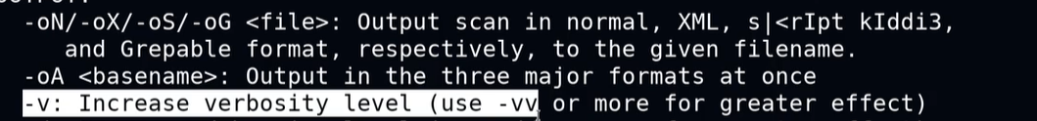
-oX is inserted in the Metasploit framework.

The Metasploit use the postgresql to store the data in msf.
For this we have to start the postgresql service.
Service postgresql start
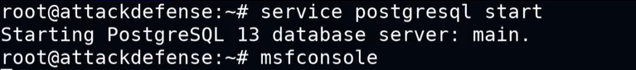
Then we have to create or use the appropriate workspace.
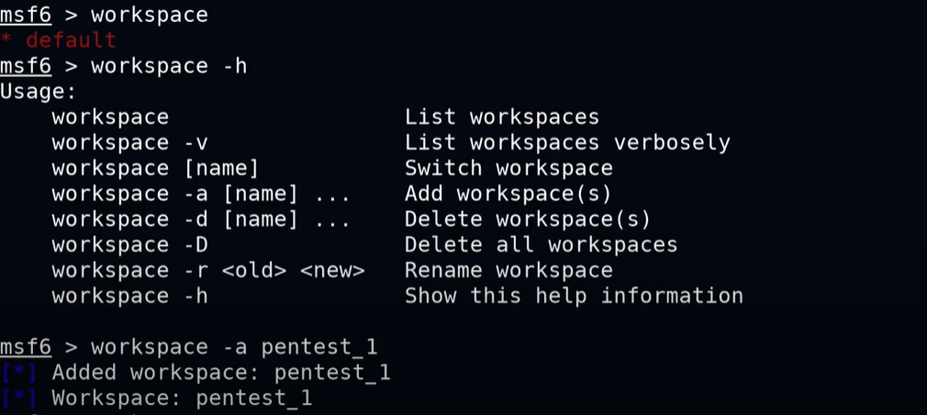
The workspace in the red color means we are using that workspace.
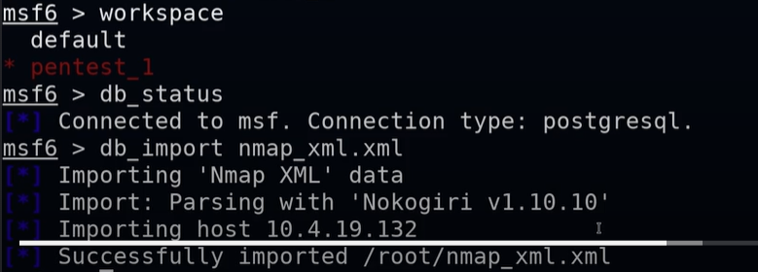
Then use host to know which host we imported:
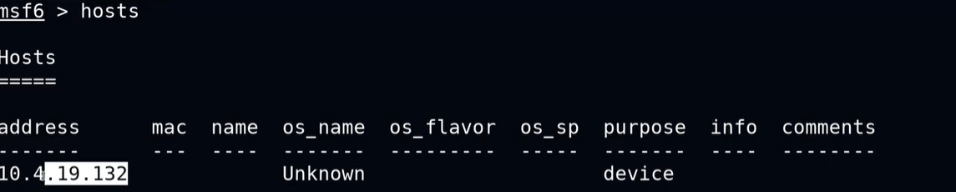
We can also see the services and open ports:
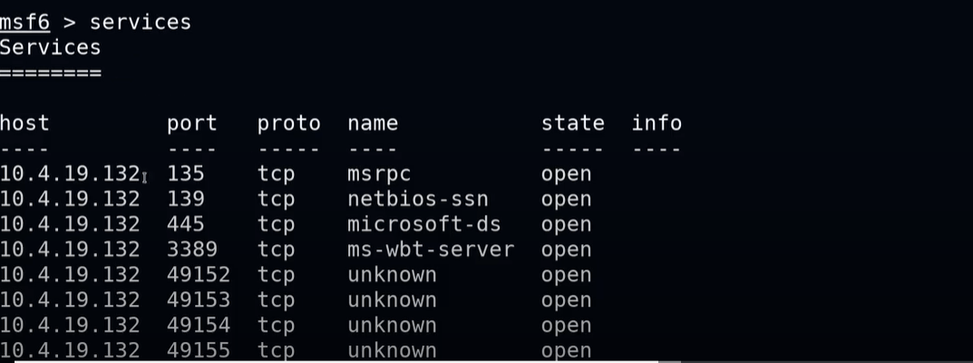
We can also run the nmap command In the msf:
When we use the db_nmap command it will automatically framework database workspace.
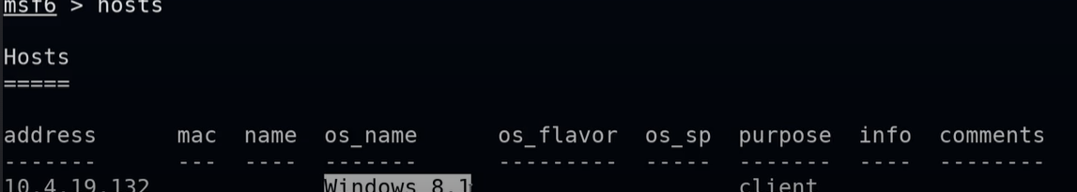
Info updated.
The information is limited to the workspace in which it is used or saved.

egrep, cut, sed, and awk used to clean and format Nmap grepable output (nmap_grep.txt) into a more readable list of host IPs and open ports with their details.

